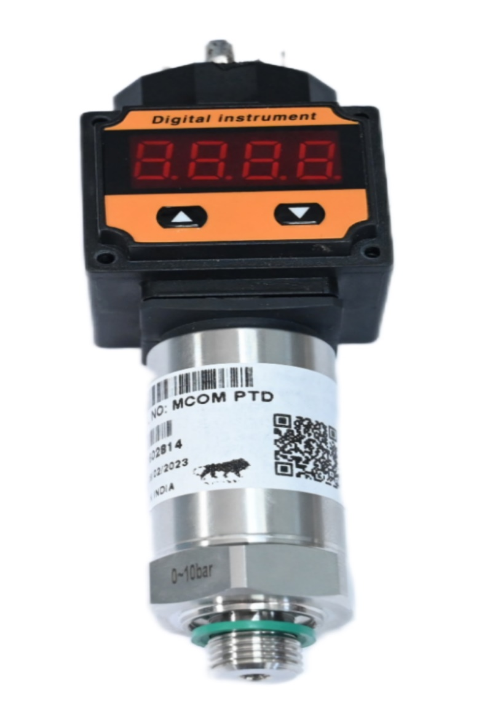
MCOM-PDT
PRESSURE SENSOR WITH DISPLAY
MCOM-PDT series pressure transmitter incorporates a media isolated silicon pressure sensor with range from 0 bar to 10 bar. For OEM that need consistent high levels of performance, reliability and stability the PDT series unit series units offer all 316L stainless steel wetted parts at an unbeatable price performance ratio. A wide choice of output signal types in addition to various electrical connection and pressure port types means the unit is suitable for most applications without modification

MCOM-PDT
PRESSURE SENSOR WITH DISPAY

RS232/RS485 MODEM

APPLICATION
- Water Pressure Measurement
- Liquid and Gas Pressure Measurement
- Hydraulic Systems
- Engine Fuel Pressure Measurement
- Refrigerator and Air compressor
- Autoclaves and ETO Sterlizers
- sewage treatment, water supply, petroleum chemical and pharmaceutical industry

FEATURES
- Gauge, Absolute and Vacuum Pressure Measurement
- Measuring Ranges From 0 to 10 bar (other ranges on request)
- Process Temperature from -40 to +125°C
- Wide Range of pressure Ports and Electrical Connectors
- Housing and Diaphragm made of Premium Stainless Steel
- Customized OEM Version Available

PERFORMANCE
- Accuracy ≤ ±0.25% BFSL
- Stability ≤ ±0.25% FS
- Insulation Resistance >100MΩ/500VDC
- Over Range Protection 300%F.S.( ≤70kPa) , 200%F.S.(<10Mpa)
- Temperature Drift <+1.5% FS(-20 to 85°C)
- Response Time ≤150ms (up to 90%F.S.)
- Reverse Polarity Protection Yes
THERMAL
Temperature
- Ambient Temperature -20°C to 85°C
- Medium Temperature -40°C to 100°C
- Storage Temperature -40°C to 110°C
Thermal Limits
- Compensated Range 0°C to 70°C
- TC Zero ≤ ±1.5% FS
- TC Span ≤ ±1.5% FS
ENVIRONMENTAL
- EMI/RFI Protection Yes (Electromagnetic Compatibility Directive 2014/30/EU)
- IP Rating IP67
- Vibration 20g (25∿2000HZ) Sine Curve; IEC 60068-2-6
- 200g/1ms; IEC 60068-2-27
ELECTRICAL
- Output 4-20mA/HART 1-5V, 1-6V, 0-4V (3 wire) 0-10V (3 wire)
- Excitation 10-30VDC 10-30VDC 15-30VDC
WIRING GUIDE
Output | Pin 1 | Pin 2 | Pin 3 | Pin 4
4-20mA (2-wire) | +V | -V | N/A | N/A
Voltage (3-wire) | +V | Ground | Signal | N/.A
mV (4-wire) | Signal | Ground | +V | -Signal

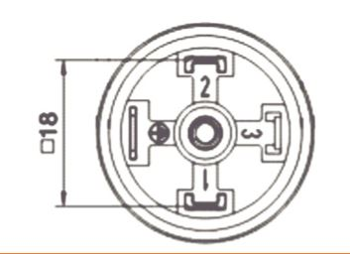
MODERN COMMUNICATION TECHNOLOGY Sr No. 23, Hissa No. 3/1, Behind Wadekar Industries, Narhe, Pune-411041 MOB.+91 9405134829, 7769827105, 9595383766
Web:-www.mcomtechnology.com

