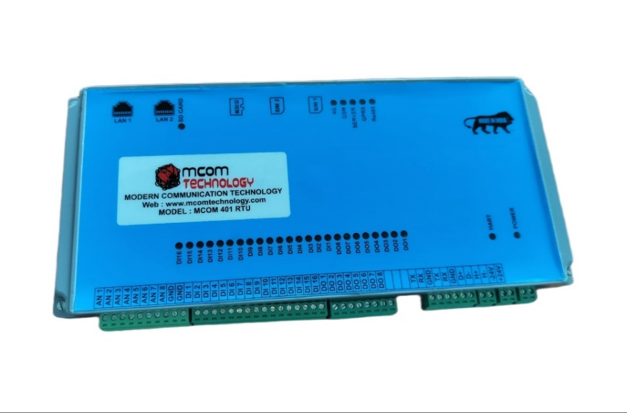
4G,3G,2G,IOT BASED RS232/RS485 MODEM

MCOM40ORD RTU is a rugged cellular MODEM offering state-of-the-art mobile connectivity for machine to machine (M2M) applications.
This device is suitable for data monitoring and operation from remote device, and for remote PLC or any MODBUS communication via serial port, Ethernet, HART and also have inbuild 8 channel analog input, 16 channel digital input & 8 channel digital output. The minimum data rate from remote to central server is 1 sec. Comes with two sim , two ethernet port and micro sd card
.

MCOM-400RD

MCOM-4000RD

RS232/RS485 MODEM

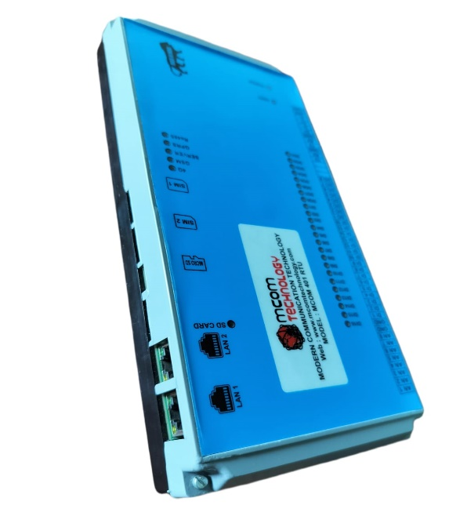
FEATURES
- Source-type Digital Outputs
- Sink-type Digital Inputs
- Photocoupler Isolation
- 8-channel Single-ended for Analog input.
- Resolution: 12 bit for Analog input
- Voltage Inputs and Current Inputs for
- 2-Ethernet switch
- 2-sim
- Micro-sd
- Watchdog
- DIP Switch for device configuration
- Cost-effective
- Wide Operating Temperature Range: -25 °C ~ +75 °C

CELLULAR INTERFACE
- Standards: GSM/GPRS/EDGE/UMTS/HSPA/FDD LTE
- GPRS/EDGE: 850/900/1800/1900 MHz
- HSUPA: 900/2100 or 850/1900 MHz optional, DL/UL 7.2/5.76 Mbps, fallback to 2G.
- HSPA+: 850/900/1900/2100 or 900/2100 or 850/1900 MHz optional, DL/UL 14.4/5.76 Mbps, fallback to 2G, FDD LTE: 800/900/1800/2100/2600 MHz or 700MHz (B17 or B13) optional, DL/UL 100/50 Mbps, fallback to 3G/2G.
- SIM: 2 x (3V & 1.8V)
- Antenna Interface: SMA Female, 50 ohms impedance.32-bit high performance microcontroller MCU

IO SPECIFICATIONS
Digital Input
Input Channels | 8 Input channel
Type | Wet Contact (Sink)
On Voltage Level | +12.0 VDC ~30 VDC
Off Voltage Level | +11 V max.
Input Impedance | 10 KΩ, 0.66 W
Digital Output
Output Channels | 8 Digital Output channel
Type | Open Collector (Source)
Max. Load Current | 500 mA/channel
Load Voltage | +12 VDC ~ +30 VDC

Analog Input
Input Channels | 8 Single-ended
Type | 0 ~ 500 mV/ 0 ~ 1 V/ 0 ~ 2.5 V/ 0 ~ 5 V/ 0 ~ 10 V/ 0 ~ 20 mA/ 4 ~ 20 mA
Resolution |  | 12-bit
Sampling Rate |  | 100 Hz total
Accuracy |  | +/-0.1%
Zero Drift |  |  | +/- 20 μV/°C
Span Drift |  |  | +/- 25 ppm/°C
Input Impedance |  |  | Voltage | 10 MΩ
 |  |  | Current | 100 Ω
Overvoltage Protection |  |  | 120 VDC
Open Wire Detection for 4 ~ 20 mA |  |  | Yes
SYSTEM SPECIFICATIONS
Communication
Interface | RS-485,RS232,HART
Format | (N, 8, 1), (N, 8, 2), (O, 8, 1), (E, 8, 1)
Baud Rate | 1200 ~ 115200 bps
Protocol | Modbus/RTU
Watchdog | Yes
Power Requirements
Reverse Polarity Protection | Yes
Powered from Terminal Block | Yes, 12 ~ 30 VDC
Consumption | 0.5 W Max.
Environment
Operating Temperature | -25 °C ~ +75 °C
Storage Temperature | -30 °C ~ +75 °C
Humidity | 10 ~ 95% RH, Non-condensing

APPLICATION
- Industrial Automation
- Industrial Machinery
- Building Automation
- Food and Beverage Systems
- Semiconductor Fabrication
- Control Systems

INSTALLATION OVERVIEW
- CAUTION:
- Circuit breaker or mains switch must be installed between power source and supply terminal to facilitate power ‘ON’ or ‘OFF’ function. However, this switch or breaker must be installed in a convenient position normally accessible to the operator.
- The equipment shall not be installed in environmental condition other than those mentioned in this manual.
MECHANICAL INSTALLATION:
- Mechanical dimension: L x W x H: 250 x 110 x 35 mm
- Mounting:
Mounting on din 35 Rail (35 x 7.5 x 0.8 mm) which is MCB-type din rail is used as Standard mounting channels for mounting Din Rail Equipment, MCBs & Terminals.

MODERN COMMUNICATION TECHNOLOGY Sr No. 23, Hissa No. 3/1, Behind Wadekar Industries, Narhe, Pune-411041 MOB. +91 9405134829, 7769827105, 9595383766
Web: -www.mcomtechnology.com

