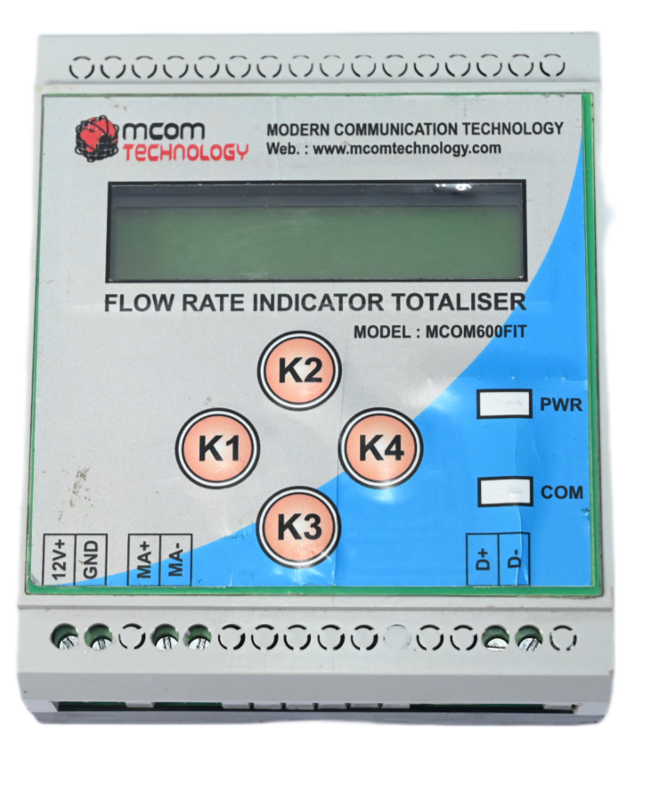
MCOM-600FIT
FLOW RATE, TOTALIZER INDICATOR
MCOM-600FIT is a microcontroller based flow rate, totalizer indicator with a 16x2 LCD display.
- Display 1st line shows the Totalizer and the Display 2nd line shows Flow Rate.
The process flow rate can be shown or calculated as per requirement in M3/Hr, Ltr/Min, Ltr/Sec etc
The flow sensor will provide 4 to 20 mA input to the flow rate indicator. The display will indicate the flow rate as per selectable range value.
- If the lower range set to 0000 and higher range set to 99999, then at 4mA input display shows 0000 and at 20mA input display shows 99999 selected higher range.
- In total flow point is fixed 7 digits.

MCOM-600FIT
FLOW RATE, TOTALIZER INDICATOR

RS232/RS485 MODEM

SERIAL COMMUNICATION
Interface standard and protocol | RS485
Communication address | 1 TO 255
Transmission mode | Half duplex
Transmission distance | 1000m for RS485
Transmission speed | 2400, 9600,19200 (in bps)
Data type | Integer, Float, Hex
Parity | None, Odd, Even
Stop bit | 1 or 2
Response time | 1000ms

Performance Parameters
Operating Temperature | -25 to 85°C
Storage Temperature | -40 to 85°C
Humidity | 5 to 95% RH
Input Voltage | 10 to 40 VDC
Power Consumption | Idle: 100 mA @ 12 V, Data Link: 500 to 1000 mA (peak) @ 12V
Dimension (L x W x H) | 110 x 94 x 35 mm
INPUT(mA) | 4 to 20 mA

Display
Line 1: 10 digit display indicating current reading of TOTAL FLOW.
Line 2: 6 digit display will show FLOW RATE.

Front keys
K2
K4
K1

K3

*Above mentioned keys are used to set the parameters and enter password

SR NO | FUNCTION | DISPLAY | RANGE
1 | Low range | Low range | high range
2 | High range | High range | 0000 to 99999
3 | Unit | Unit | LPS,LPM,LPH,M3/ Hr
4 | Decimal point selection | Set Decimal  Point | 0.000 to 0000.

Parameter setting
1. Set Unit
- Press K2 key for 3 sec and enter password (press K3 three times) to change
- LPS ,LPH, M³/Hrs, Kg/Hrs
- Use K2/K3 key to select the parameter
- Use K4 to save selected unit
- Flow Rate Line will indicate LPS or LPH or M³/ Hrs or Kg/Hrs.
2. Set Flow Decimal
- Press K2 key for 3 sec and enter password (press K3 three times). Again press K4 key to Set Flow Decimal.
- Use K2/K3 key to select Flow Decimal.
- Use K4 to save selected Flow Decimal.

3. Set low range:
- Press K2 key for 3 sec and enter password (press K3 three times)..
- Press K4 key two times.
- Display will indicate Set Low Range.
- Press K1 key to shift editing digit and K2/K3 key to change editing digits value.
- Maximum value of low range selection will be < higher range.
4. Set High Range
- Press K2 key for 3 sec and enter password (press K3 three times).
- Press K4 key three times.
- Display will indicate Set High Range.
- Press K1 key to key to shift editing digit and K2/K3key to change editing digits value.
- Display will indicate High range up to 9999.
- Maximum value of Flow range selection will be 9999 M³/Hrs

5. Set Scale factor
- Press K2 key for 3 sec and enter password (press K3 three times).
- Press K4 key four times.
- Display will indicate Set Scale Factor.
- Press K1 key to key to shift editing digit and K2/K3key to change editing digits value.
- Range of scale factor varies between 0.01 to 2.99.

6. Set Hysteresis
- Press K2 key for 3 sec and enter password (press K3 three times).
- Press K4 key five times.
- Display will indicate Set Hysteresis.
- Press K1 key to key to shift editing digit and K2/K3key to change editing digits value.
- Rage of Hysteresis varies between 00.1 to 99.9. Hysteresis only applies in batching function.

7. Set Batch1 Count

- Press K2 key for 3 sec and enter password (press K3 three times).
- Press K4 key six times.
- Display will indicate Set Batch1.
- Press K1 key to key to shift editing digit and K2/K3 key to change editing digits value.
- Display will indicate batch1 count up to 999999.999.
- Press K4 to save batch1 count. Pulse on LED1 and Relay1 indicates batch has completed and Current Batch count1 will get incremented by 1 and batch comparison will proceed for next batch according to unit and decimal point set by user and flow rate.
To Reset Relay press K3 for 2 Sec.
Then next batching operation will start.

8. Baud Rate:

- Press K2 key for 3 sec and enter password (press K3 three times).
- Press K4 key seven times.
- Display will indicate Baud Rate.
- Use K2/K3 key to select the parameter 2400/9600/19200.
- Use K4 to save selected baud rate
- Flow Rate Line will indicate baud rate 2400 or 9600 or 192000 that is used for 485 communication.
9. Slave ID
- Press K2 key for 3 sec and enter password (press K3 three times)..
- Press K4 key eight times.

- Display will indicate Slave ID.
- Press SW1 key to shift editing digit and K2/K3 key to change editing digits value.
- Slave id can be selected in range 1 to 249 which is used as device id for 485 communication to transfer running data of current device to remote host.

10. Parity

- Press K2 key for 3 sec and enter password (press K3 three times).
- Press K4 key nine times.
- Display will indicate Parity bit.
- Use K2/K3 key to select the parameter NONE/ EVEN/ ODD.
- Use K4 to save selected parity bit
- Flow Rate Line will indicate parity bit NONE or EVEN or ODD that is used for 485 communication.

Working
- When power is supplied to the instrument the display will show the present flow rate.
- Display 1st line shows the Total Flow and the Display 2nd line shows Flow Rate.
- The process flow rate can be shown or calculated as per requirement in cubic meter per hour etc.
- The flow sensor will provide 4 to 20 mA input to the flow rate indicator. The display will indicate the flow rate as per selectable range value.
- If the lower range set to 0000 and higher range set to 9999, then at 4mA input display shows 0000 and at 20mA input display shows 9999 selected higher range.
- In total flow point is fixed 7 digits.
- If u want to reset the total flow want to reset the total flow count on the display, you can press SW3 for 3 sec then Password will be seen on the LCD screen, press SW1 key three times as a password. You will see two options as Yes: ENT; No: SET, Press SW4 key to reset the total flow or press SW1 key to exit without reset.
- If input is not connected, display will show OPEN msg.

Enter Password
There are four modes in which you have Password which are mentioned below:
1) Configuration Parameter Mode
- Press K2 for 3 sec, then Password will be seen on the LCD screen, press K3 key three times as a password. Now you can set the Parameter as per your choice.
2) Reset Mode
When you want to reset the total flow count on the display or batch1 count follow procedure given below.
- RESET TF

- PressK3 for 3 Sec then Password will be seen on the LCD screen, press SW1 key three times as a password.
- You will see two options as Yes: ENT; No: SET, Press SW4 key to reset the total flow or press K1 key to exit without reset.

- RESET BATCH 1 COUNT

- Press K3 for 3 Sec then Password will be seen on the LCD screen, press K1 key three times as a password.
- Press K1 once then you will see RESET BATCH1 and two options as Yes: ENT; No: SET, Press K4 key to reset the BATCH1 count or press K1 key to exit without reset.
3) Calibration Mode
To calibrate the Totalizer between 4 mA to 20 mA, you use can press K4 for 3Sec then Password will be seen on the LCD screen, press SW2 key three times as a password. Follow the instructions and then calibrated the Totalizer.
4) Password Exit Mode
In any of the above condition you don’t want to enter any password or you want to exit from password screen then wait for 9 sec you will automatically exit from password option.
5) Range Display Mode
By short press K2 user can be able to view low range and high range values stetted by himself. Again short press of K2 will go to home window with TF and FR display (or no any key press will automatically switch within next 6 sec).
6) Batch Display Mode
By short press sw3 user can be able to view batch1 amount and batch1 count. Again short press of K3 will go to home window with TF and FR display (or no any key press will automatically switch within next 6 sec).

Special Features
- Advanced 16bit Microcontroller based design.
- Easy user-interface through tactile keypad.
- Flexibility in range change without recalibration
- User defined range and resolution of the display.
- Online data logging: through RS 485 with parity checking.
- Huge capacity of counter up to 9999999.999 units
- Flow batching facility available.
- Password protection user programming calibration & totalizer reset.
- User selectable units for flow rate: M3/Hr, Ltr/Min, Ltr/Sec etc.

CONNECTION DETAILS
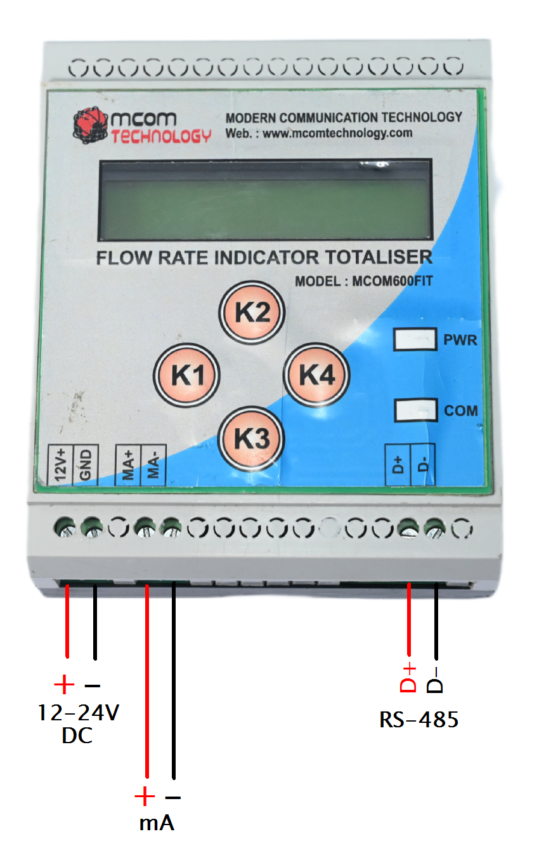

INSTALLATION OVERVIEW
- CAUTION:
- While Installation, please keep the AC power supply cable, PLC output module, relay and other type electrical equipment far from the modem.
- Circuit breaker or mains switch must be installed between power source and supply terminal to facilitate power ‘ON’ or ‘OFF’ function. However this switch or breaker must be installed in a convenient position normally accessible to the operator.
- The equipment shall not be installed in environmental condition other than those mentioned in this manual.

- MECHANICAL INSTALLATION:
- Mechanical dimension: L x W x H: 110 x 94 x 35 mm
- Mounting:
Mounting on din 35 Rail (35 x 7.5 x 0.8 mm) which is MCB-type din rail is used as Standard mounting channels for mounting Din Rail Equipment, MCBs & Terminals.
