
MCOM100CHMI
Human Machine Interface

RS232/RS485 MODEM

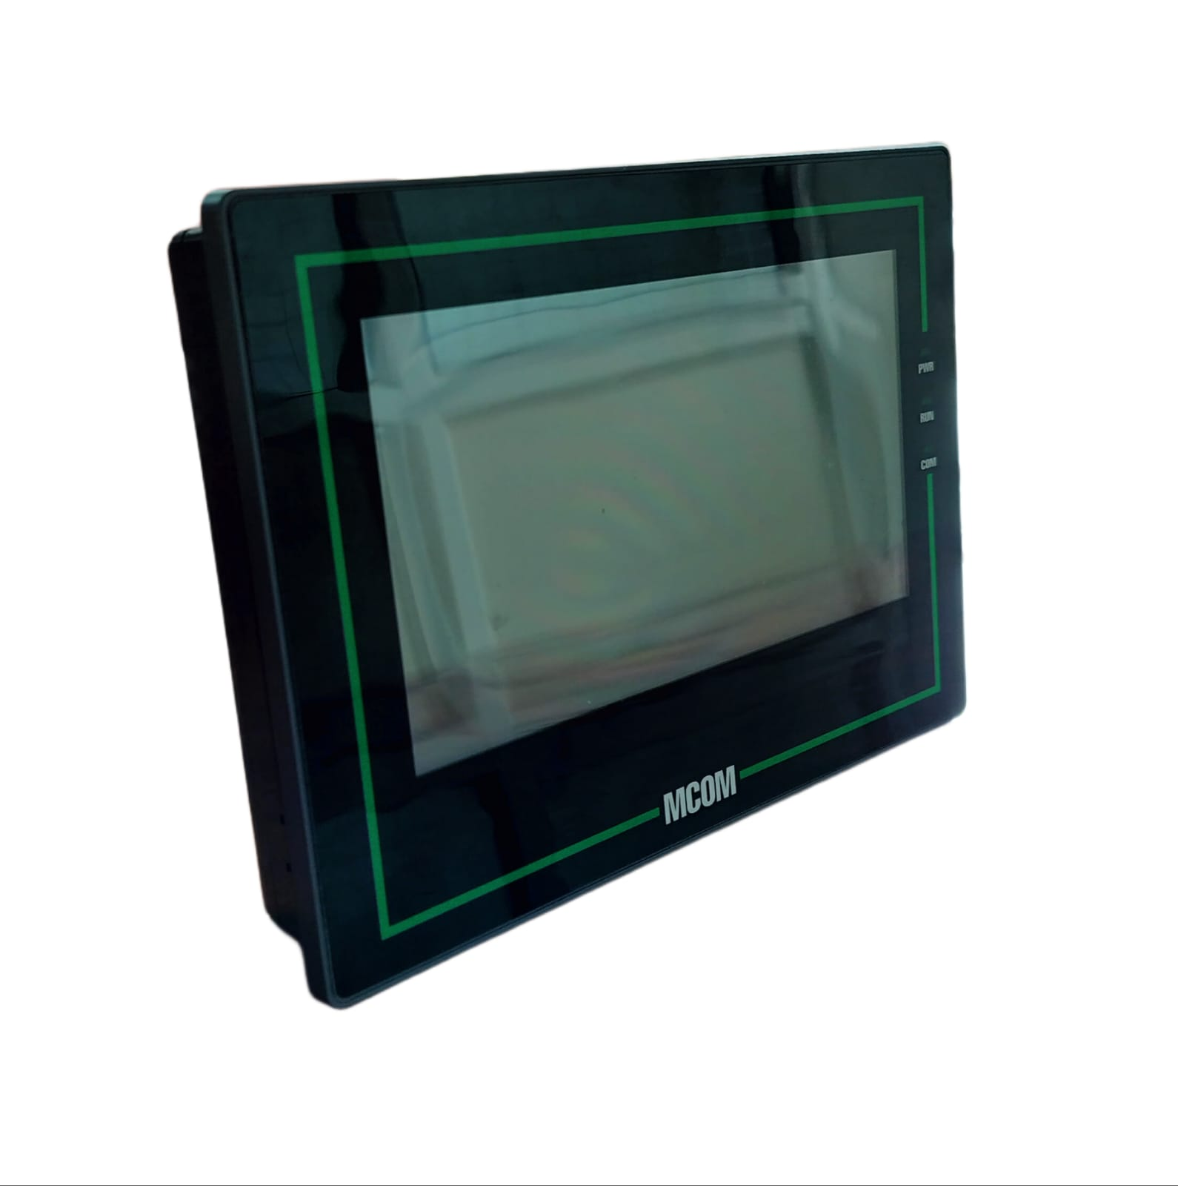
Features:
- 7’’ Touch screen
- In-Built symbol library
- Address Mapping
- Update program by USB flash
- Alarm, Calendar, Real time clock
- Muli-Serial communication
- User / Recipe management
- Script function

Specifications |  | MCOM101RTUCHMI
Display specification | Type | 7’’ Touch screen
Display specification | Resolution | 800 X 480
Display specification | Display size | 7” Diagonal
Display specification | Backlight | LED
Display specification | Span life | 50000 hrs
Display specification | LCD Type | High precision four-wire resistive
Display specification | Brightness | 450cd/m2
Functional specification | Programming | Windows based software for HMI
Functional specification | Processor | Cortex A-7 1GHz
Functional specification | OS | Linux 4.9.11 QT based
Functional specification | Memory | 128M Flash + 64MB RAM
Functional specification | USB | USB2.0 Host + USB2.0 Client
Functional specification | USB slave | Type B, program download/upload only
Functional specification | Serial interface | COM1: RS232, COM2:RS485/422
Functional specification | Ethernet Communication | Yes
Functional specification | DB9 | Male(COM1)
Functional specification | Real-time clock | Yes
Mechanical specification | Dimensions(WxHxD) MM | 203 x 145 X 35
Mechanical specification | Mounting | Panel Mounting
Mechanical specification | Weight | 0.7Kg
Mechanical specification | Ingress protection | IP65 (Front panel)
Mechanical specification | Cover material | PC+ABS plastics
Electrical  specification | Power supply voltage | 24V DC (DC 12∿24V)
Electrical  specification | Rated power | < 15W
Environmental  specification | Temperature | Operating: -10∿60 °C | Storage: -20∿70 °C
Environmental  specification | Humidity | 10∿90% RH (Non-condensing)
Environmental  specification | Seismic performance | 10∿25Hz (2G/30min in x,y,z directions)

Dimension
All Dimensions are in mm
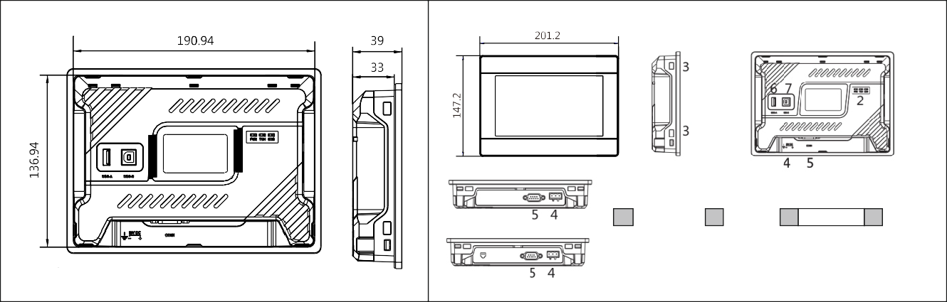
35
203
Panel cutout cutout
7" HMI
8
Panel cutout

145

DB9 Pin Configuration
Interface | PIN | PIN
COM1 | 1
COM1 | 2 | RS232 RXD
COM1 | 3 | RS232 TXD
COM1 | 5 | GND
COM1 | 6
Interface | PIN | PIN
COM2 | 1
COM2 | 2
COM2 | 3
COM2 | 7 | RS485 A+
COM2 | 8 | RS485 B -

MODERN COMMUNICATION TECHNOLOGY Sr No. 23, Hissa No. 3/1, Behind Wadekar Industries, Narhe, Pune-411041 MOB.+91 9405134829, 7769827105, 9595383766
Web: -www.mcomtechnology.com

